Music development plan summary:
Deanery CE Primary School

Overview
Detail | Information
Academic year that this summary covers | 2025-2026
Date this summary was published | January 2026
Date this summary will be reviewed | September 2026
Name of the school music lead | Katie Jenner
Name of school leadership team member with responsibility for music (if different)
Name of local music hub | Services for Education
Name of other music education organisation(s) (if partnership in place)

This is a summary of how our school delivers music education to all our pupils across three areas – curriculum music, co-curricular provision and musical experiences – and what changes we are planning in future years. This information is to help pupils and parents or carers understand what our school offers and who we work with to support our pupils’ music education.

Part A: Curriculum music
This is about what we teach in lesson time, how much time is spent teaching music and any music qualifications or awards that pupils can achieve.
The aims of music as outlined by the National Curriculum are to enable children to:
- Perform, listen to, review and evaluate music across a range of historical periods, genres, styles and traditions, including the works of the great composers and musicians.
- To learn to sing and to use their voices.
- To create and compose music on their own and with others.
- To have the opportunity to learn a musical instrument.
- To use technology appropriately.
- To have the opportunity to progress to the next level of musical excellence.
- Understand and explore how music is created, produced and communicated, including through the inter-related dimensions: pitch, duration, dynamics, tempo, timbre, texture, structure and appropriate musical notations.

Music lessons are taught fortnightly using the Kapow scheme, providing a structured and engaging approach to musical learning. Lessons are taught by class teachers. As a school, we follow the condensed version of the curriculum. Each year group teaches four units, each unit comprising of five lessons.
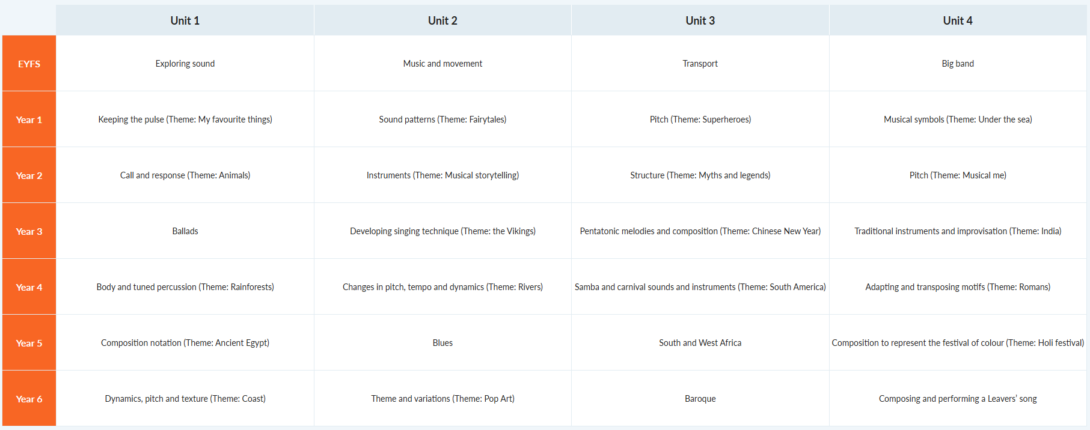
The Kapow Primary Music scheme is designed to help pupils recognise themselves as musical and to nurture a lifelong love of music.
The scheme develops the skills, knowledge, and understanding needed to become confident performers, composers, and listeners. The curriculum introduces pupils to music from across the world, encouraging respect and appreciation for the music of all traditions and communities.
Pupils build musical skills through singing, playing tuned and untuned instruments, improvising, composing and listening and responding to music. They develop an understanding of the historical and cultural context of the music they encounter and learn how music can be notated.
Every lesson is structured as follows:
- Recap and recall - a short activity revisiting prior learning to help reinforce key knowledge, activate long-term memory and create connections between past and new learning.
- Attention grabber – A short, engaging activity designed to hook pupils into the new learning in the lesson.
- Main event – The core part of the lesson, where pupils engage in activities that develop their understanding of the learning objective. This includes a mixture of teacher modelling, guided practice and independent or collaborative tasks tailored to support all learners.
- Wrapping up - A final reflective activity that consolidates learning.

Part B: Music tuition, choirs and ensembles
This is about opportunities for pupils to sing and play music, outside of lesson time, including choirs, ensembles and bands, and how pupils can make progress in music beyond the core curriculum.
Through our partnership with ‘Services for Education’, children are offered the opportunity to study a musical instrument with peripatetic teachers. Peripatetic music teaching is organised by the Local Education Authority’s Music Service with the exception of a few private tutors. Parents who want their children to participate in these must pay the additional music lesson fees on a termly basis. These lessons are normally taught to small groups of children who have chosen to learn one of a variety of instruments, such as the clarinet, saxophone, keyboard, piano, violin, recorder or drums and take place within the school day. Pupils are able to take graded exams for their specific instrument.

Part C: Musical experiences
This is about all the other musical events and opportunities that we organise, such as singing in assembly, concerts and shows, and trips to professional concerts.
Music is used within our collective worship time. It may be that children listen to music or are actively singing a song. There is a weekly ‘song’ practise for each Key Stage. This music assembly is sometimes in preparation for church assemblies or musical performance and on other occasions it is purely to learn about and enjoy music and singing. Music is performed both live using the piano and recorded mediums.
As part of collective worship assemblies, music is played for the children to listen to and think about as they enter and leave the assembly.
Teaching staff are encouraged to use music within their classrooms so children encounter music being used in a variety of ways – such as focusing attention, motivating or inspiring children.
Pupils who are taking music lessons are all invited to perform in an assembly to showcase their musical skills. Parents and family members are invited in to watch these assemblies.
We celebrate Sky Arts’ Creative Arts week each year – a week of lessons that focus on the creative arts including music. We invite in guests to come and run workshops and performances for the children on a range of different instruments.
Christmas is a busy time featuring lots of Christmas productions and church services – all with music at their heart. These are attended by other classes from the school and parents/guardians and family members.
As an entire school, each Christmas we attend a pantomime performance in Lichfield to expose children to live music and theatre. The tickets for this are subsidised by the PTFA and parents then pay the costing for travel.
As a Church of England school, a range of worship ceremonies are led by the children at our local church (St. John’s, Walmley). These include harvest festival, Advent service, Easter service and the Year 6 leavers service. All of these services include worship songs.
Towards the end of the academic year, Year 6 perform a ‘leavers play’. These always feature musical numbers. To accompany this, when possible, Year 6 go to the theatre and see a performance of the production they will be performing.
Within school, we offer music instrument lessons to the pupils. This is provided by Services for Education and parents pay for these lessons.

In the future
This is about what the school is planning for subsequent years.
- Ensure the new scheme introduced (Kapow) is being consistently implemented.
- In collaboration with other arts subjects, work towards an Artsmark Award.
- Singing assemblies to continue as led by Music Lead focussing on worship songs.
- Continue to work and develop a dedicated music teaching space.
- Further develop performance opportunities for our young musicians throughout the school year (both curriculum music and extra-curricular).
- Music lead to attend CPD training to feedback to members of staff to ensure music is being taught consistently and progressively across the school.
- Research/plan whole class instrumental lessons (clarinet) for Year 4 taught by the music lead within school.
- Explore the possibility of having music extra-curricular clubs such as choir, recorder ensemble etc alongside performance opportunities such as Young Voices, Services for Education youth proms.
- Research other opportunities for children to experience live music.

Further information (optional)
Services For Education,
Unit 3,
Holt Court,
Birmingham Science Park Aston Faraday Wharf,
Holt St,
Birmingham
B7 4AX
https://www.servicesforeducation.co.uk/music-service/

