 | Deanery CE Primary School  Academy Status

Relationship / Behaviour Policy
April 2025
The Deanery School Christian Ethos
Our School Motto – ‘Ad Majorem Dei Gloriam’
Translated this simply means ‘To the Greater Glory of God’.

Vision
We believe that everything we do is a faithful response to God’s faithfulness, shown to us through Jesus Christ. Our vision is to reflect God’s Glory in every season of life, in all aspects, from the little things, to the big.

Beliefs and Values
We believe that God’s heart is for his children to thrive in a happy, secure, and caring environment at the Deanery. It is an essential part of our Christian ethos that we thank God for how he has demonstrated peace, love, faith, joy, grace and hope to us. We seek to reflect these core values throughout all areas of life in the school.
We believe that education, strengthened by our faith, is the vehicle with which children can achieve their full potential.

School Culture
At the Deanery we aim to provide opportunities and experiences for everyone to learn and develop their social, creative and academic skills within a motivating and stimulating environment.

We aim to:
• Foster an environment that is enriched spiritually, morally, ethically and socially through the Christian faith.
• Value each child as unique, regardless of faith, ability, gender or ethnicity.
• Nurture children to be polite, respectful and considerate towards one another.
•Offer a range of opportunities and experiences to develop their confidence, self-esteem and independence.
• Encourage each child to fulfil their potential within all areas of the curriculum.
• Promote knowledge and understanding through a secure, stimulating and enriched environment.
• Create a broad educational experience that is enriched both morally and spiritually through partnership with staff, governors, parents, the local community, parishes of the Deanery and Birmingham Diocese.
• Enable each child to value themselves and have aspirations for the future.
• Recognise everyone’s place in the wider community.

The Deanery school culture of behaviour is positive, consistent and kind. A culture based on forming positive relationships where every adult is flexible to change, present in the toughest moments and focussed on keeping children safe; where the expectations on all are high and where behaviour is not a limit to achievement.

Our Relationships Policy is based on the Five Pillars of Pivotal practice

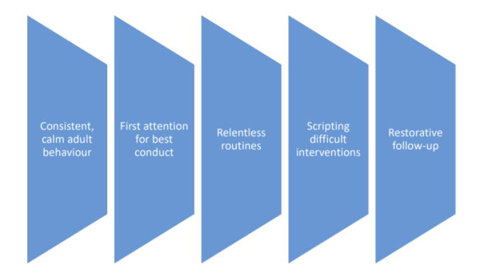

“When the adults change, everything changes” (Pivotal Education)

EXPECTATIONS:

We expect all children to consistently make the right choices. This behaviour is underpinned by our school values, and our three school rules.

Our school values are:
• Love
• Joy
• Peace
• Grace
• Faith
• Hope

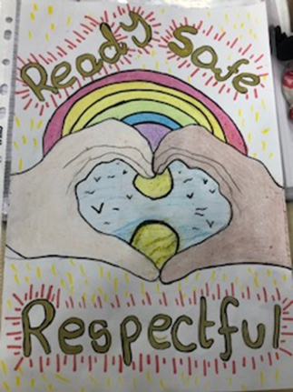
Our School Rules are:
Ready (having equipment organised, appropriate behaviour in class and assemblies)
Respectful (to be polite, to consider others’ feelings, to wait their turn, to accept a solution or a consequence, to care for school equipment, to value each other’s work)
Safe (walk around school calmly and quietly, work and play co-operatively, tell the truth)

These key words are prominently displayed in our school hall, classrooms and corridors. Assemblies frequently explore what each value entails, so that there is a mutual understanding of what it means to ‘Behave the Deanery Way’ and what, as a school community, we can do to uphold the expectations. We also have a child produced guide ‘This is how we do it here’ outlining what it looks like to be Ready, respectful and Safe at Deanery.

These expectations are achieved by:
• Encouraging students to develop positive behaviour for learning in recognition of its importance as a lifelong skill.
• Providing a safe, happy and friendly environment which encourages each individual to achieve their own potential through a desire for excellence, using challenging, active and creative personalised learning.
• Enabling staff to support children with their behaviour through providing students with strategies to manage their own behaviour.
• Maintaining a calm and purposeful working atmosphere.
• Ensuring that all children and adults have a sense of belonging, feeling safe, secure and valued.
• Providing a clear, fair and consistent approach to behaviour.
• Fostering, nurture and value strong and healthy relationships.
• Ensuring that our children are intrinsically motivated to do the right thing because it is the right thing to do.
• Ensuring that there is complete consistency from staff in the implementation of the policy.

'The foundation of every school must be excellent behaviour. We should be keeping the focus on a visible culture of impeccable conduct, and making the consistency palpable, audible and highly visible.' - Paul Dix

We expect children to:
• Follow the three school rules: Be ready, Be respectful, Be safe.
• Be respectful to one another, speak calmly and courteously.
- To respect the feelings of others and to treat everyone as they would like to be treated.
• Do the simple things right – arrive in school on time, wear our school uniform with pride, bring the correct equipment for learning.
• Speak to an adult if they have any concerns.
• Work restoratively to avoid conflict and respect the right of others to be different.
• Listen to the views of others and accept their rights to hold those views.
• Respect the school building, facilities and equipment.

The principle behind our behaviour system is that we want children to make positive behaviour choices because it is the right thing to do not because of the promise of a reward or the threat of a punishment. After all, no one rewards us as adults for sticking to the speed limit! We want children to recognise that we need to follow rules for the greater good i.e. stick to the speed limit because it keep us and others safe.

Consistent, calm adult behaviour
We expect that staff will:
• Be ready, Be respectful, Be safe.
• Be great role models for pupils and peers.
- Treat children equally, irrespective of gender, race, disability, SEN or other equalities.
- Encourage pupils to show respect for members of the community and the environment.
- Be fair, calm and consistent in how they treat all situations, involving all children
• Speak politely and calmly and respect everyone’s personal space.
• Develop positive relationships with pupils, parents and colleagues.
• Treat all members of the community equally, fairly and consistently, meeting their individual needs.
• Pass on the positive
- Follow relentless routines- consistent routines for e.g. lining up – that are shared widely with all staff to ensure consistency for the children
- Meet and Greet –a member of staff from each year group is outside each morning to greet the children. This is to provide a moment of connection at the start of the day.

However, our children are all unique, which means that our relationships policy must reflect that: conversations that work with one child will not have the same effect on another. Luckily, we know all our children really well, so can tailor these as needed.

We expect that parents and carers will:
• Be ready, Be respectful, Be safe.
• Work in partnership with the school staff to ensure that their child is able to achieve to the best of their ability.
• Respect school decisions and follow procedures within in policies.
• Ensure that their child is in school on time, dressed in the correct uniform.
• Support their child with their learning at home.
• Support the school in modelling polite, calm and orderly behaviour
• Encourage their child to show respect for members of the school community and the environment.
• Work with the school to ensure their child follows the three school rules: Be Ready, Be Respectful, Be Safe.

POSITIVE PRAISE:

The following positive strategies will be used consistently by all adults in the school. They are designed to ensure 'first attention goes to best conduct' and to create clear, simple routines and expectations that make children feel valued members of our learning community and motivated to always try their best.

'The reward enables you to mark the moment with the child. You are framing them with their best behaviour, their most determined effort, their greatest show of resilience.' - Paul Dix

- Recognition boards – each class has a focus related to one of the school rules and the aim is for all children to demonstrate this and get onto the recognition board. Once this happens, the class are rewarded although they will not be rewarded with non-learning time ie Golden Time as this sends the wrong message about learning.
- Postcards - Staff send physical postcards home, virtual emailed postcards home or make a phone call to share positive praise about children.
- Great work- children are given a sticker as positive recognition and then invited to take their great pieces of work to the subject lead for positive praise. This gives children praise from a range of staff across school.
- Tokens - we wish to give recognition to pupils who go 'above and beyond'. 'Above and Beyond' behaviours include exceeding our school values, impacting the wider school community and showing initiative. For this we award tokens.
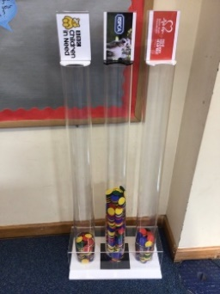
- Children are invited to donate their token to their chosen charity as a way of seeing themselves as citizens that can make a difference and can work for the greater good.
- Head boys, head girls and house captains, research and choose the 3 charities per term (e.g. local, national, international) and to run assemblies each term to explain to the school which charities we are supporting and why.
- Each term we will run a a fundraising event (only 3 per year) to raise money for the charities e.g. non uniform, enterprise activity, sponsored read etc
- The 3 charities will receive a proportion of the profits raised depending on number of votes/tokens gained for each charity. This encourages children to see the benefit of doing things for the greater good and not just for individual gain.

'If you consistently reward minimum standards then children will strive for minimum standards. If you reward children for going over and above then there is no limit to their excellent behaviour.' - Paul Dix

MANAGING INAPPROPRIATE BEHAVIOUR

'Children need people, not punishment. It is time we gave them what they need to succeed, not simply what we feel they deserve. Exclusion and heavy sanctions rarely meet the needs of the child.' - Paul Dix

At Deanery, we encourage positive behaviour which reflects our values. Our behaviour management approach is based upon building strong relationships between adults and children. The use of positive reinforcement strategies will always be our default approach.
However, we understand that occasionally children will behave inappropriately for a variety of reasons. As practitioners, we should always thinking ‘all behaviour is communication’ and what is the child trying to communicate. We realise that sometimes this can be different for every child who has their own packet of needs so may look different in each individual case. The context of the situation is to be always taken into account. When children display this behaviour, there are several layers of consequences in place to encourage them to self-regulate their behaviour in a positive way.

We employ a four tier intervention behavioural management system:

1. Verbal Reminder:
• I can see that you are choosing to
• I’ve noticed that…
• Remember the expectation for…
• This is what I’d like to see…

Move on quickly and find a child doing something positive

2. Warning:
• I can see you are choosing to…
• Can you remember when we had the last conversation and I asked for…
• At the moment I haven’t seen that…
• If there is something you need to tell me or I can help with…
If behaviour continues – a yellow ‘Warning’ card is issued to the individual. If the behaviour is modified positively, then the yellow card can be removed.

3. Second Warning
If behaviour is not modified, an additional verbal warning is issued.

4. Consequence
If behaviour continues to be inappropriate a ‘Red’ consequence card issued. In some circumstances e.g. fighting, swearing, a red ‘Consequence’ card is issued straight away.

Actions - ‘Warning’
Persistent shouting/ calling out
Throwing things/ not respecting equipment
Refusal to follow rules
Hurting others
Disrespectful to staff
Persistent disrespect to peers
Talking when they should be listening
Not following direct instructions
Acting inappropriately in cloakroom/ toilets
Name calling
Laughing at mistakes/ disrespectful to other children/ not being caring
Tormenting children
Being rude
Telling lies

Actions ‘Consequence’
Fighting/violence, including biting, kicking, hitting - harming others
Racism Inappropriate language – swearing/ homophobic
Spitting

Red and yellow cards are in place as sanctions but are recorded privately on the teacher’s desk. It should be explained to the child that they have made a wrong choice, linking feelings about the behaviour choices and not the child.

Red card letters are e-mailed to parents rather than a copy being publically given to the child.

Repeated letters will result in a meeting with the Phase Leader or Deputy Teacher where behaviour and support can be discussed. We will endeavour to work with the parents to ensure positive behaviour from all children. Repeated inappropriate behaviour may result in periods of exclusion. The health and safety of the child concerned and of other children or members of staff are paramount.

It is important to remember that children are not defined by an event. Mistakes are made and should be learnt from. Once a situation is dealt with it is finished and this needs to be clear to the child.

Pupil Support
The school recognises its legal duty under the Equality Act 2010 to prevent pupils with a protected characteristic from being at a disadvantage. As a fully inclusive school, we recognise that for some children additional or different action may be necessary as a result of a special educational need and/or disability. This is in accordance with the SEN code of practice. We recognise that a child with social, emotional and mental health needs may require something additional or different in the same way that we would make curriculum adaptations for a child with learning needs. Consequently, our approach to challenging behaviour may be differentiated to cater to the needs of the pupil. The school’s Inclusion Manager will evaluate a pupil who exhibits challenging behaviour to determine whether they have any underlying needs that are not currently being met. Where necessary, support and advice will also be sought from specialist teachers, an educational psychologist, medical practitioners and/or others, to identify or support specific needs. When acute needs are identified in a pupil, we will liaise with external agencies and plan support programmes for that child. We will work with parents to create the plan and review it on a regular basis. It may also be appropriate to help other children in school understand what they can do to support this particular pupil. Further information on the school's approach to inclusion is outlined in the Special Educational Needs Policy.

Exclusion
We recognise the damaging effects of excluding children and therefore this will only be used as a last resort in exceptional circumstances. The decision to exclude is taken by the headteacher and this may be for a fixed term or permanent exclusion. The headteacher will take into account the circumstances, evidence available and the need to balance the interests of the pupil against those of the whole school community. Parents have the right to make representations to the governing body about an exclusion and the governing body must review the exclusion decision in certain circumstances, which include all permanent exclusions. Where a governing body upholds a permanent exclusion parents have the right to appeal the decision to an independent review panel.

Criminal law
It is important to bear in mind that some types of harassing or threatening behaviour – or communications – could be a criminal offence, for example under the Protection from Harassment Act 1997, the Malicious Communications Act 1988, the Communications Act 2003, and the Public Order Act 1986. For example, under the Malicious Communication Act 1988, it is an offence for a person to send an electronic communication to another person with the intent to cause distress or anxiety or to send an electronic communication which conveys a message which is indecent or grossly offensive, a threat, or information which is false and known or believed to be false by the sender.
If school staff feel that an offence may have been committed they may elect to seek assistance from the Police, but any reference to the Police should only be undertaken with the agreement of the Headteacher.

Bullying
(See Anti-Bullying Policy)
Bullying is unacceptable at Deanery Primary School and is treated very seriously by all members of staff. If we discover that an act of bullying or intimidation has taken place, we act immediately to stop any further occurrences of such behaviour. While it is very difficult to eradicate bullying, we do everything in our power to ensure that all children attend school free from fear.
In order to prevent bullying and deal with any incidents of bullying, we employ a range of strategies
• Use of SCARF programme during PSHE
• Circle Time
• Assemblies
• Monitoring areas within the school building i.e. toilets, cloakrooms etc.
• Monitoring of playground by staff on duty.

Pupils’ conduct outside the school gates
Teachers have a statutory power to discipline pupils for misbehaving outside of the school premises. Section 89(5) of the Education and Inspections Act 2006 gives Head teachers a specific statutory power to regulate pupils’ behaviour in these circumstances ‘to such extent as is reasonable’. Subject to the school’s behaviour policy, the teacher may discipline a pupil for any misbehaviour when the child is:
• Taking part in any school-organised or school-related activity or
• Travelling to or from school or
• Wearing school uniform or
• In some other way identifiable as a pupil at the school.
Or misbehaviour at any time, whether or not the conditions above apply, that:
• Could have repercussions for the orderly running of the school or
• Poses a threat to another pupil or member of the public or
• Could adversely affect the reputation of the school.

Confiscation of Inappropriate items
There are two sets of legal provisions which enable school staff to confiscate items from pupils:
The general power to discipline enables a member of staff to confiscate, retain or dispose of a pupil’s property as a consequence and protects them from liability for damage to, or loss of, any confiscated items. Power to search without consent for “prohibited items” including:
• knives and weapons
• alcohol
• illegal drugs
• stolen items
• tobacco and cigarette papers
• fireworks
• pornographic images
• any article that has been or is likely to be used to commit an offence, cause personal injury or damage to property
• any item banned by the school rules which has been identified in the rules as an item which may be searched for.

Malicious allegations against staff members
Allegations of abuse will be taken seriously, and the Leadership Team will deal with allegations quickly in a fair and consistent way that provides effective protection for the child and supports the person who is the subject of the allegation. Every effort will be made to maintain confidentiality and guard against unwanted publicity while an allegation is being investigated. Suspension will not be used as an automatic response when an allegation has been reported. The Head Teacher will also consider the pastoral needs of staff accused of misconduct.

Policy reviewed by Anita Morris Deputy Head Teacher April 2025

Agreed and accepted by Full Governing Body

Signed 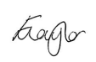

Date: 19/03/25



