Introduction
At Deanery CE Primary School, we enable our children to achieve success through a rich, diverse and inclusive curriculum with opportunities for wider experiences throughout their school journey. We provide many opportunities for our children to be motivated and enjoy learning through our lessons, educational visits, residential activities and a variety of visitors who bring different experiences of life.  It is important to us that every child is valued and their talents, skills and unique qualities are recognised. We believe in developing the whole child and actively promote and encourage a healthy lifestyle.  For further information, please see our Inclusion Policy. | 

Our Inclusion Team
Mrs J Griffiths  Inclusion Manager (incorporating the role of Special Educational Needs and Disabilities Co-ordinator - SENDCo)  Mrs S McGuinness  Special Educational Needs Teaching Assistant (SEND TA)  If your child has special educational needs and / or a disability and you would like to know more about what we offer at Deanery, please refer to our SEND Policy, contact us on 0121 351 6441 or email Mrs J Griffiths (Inclusion Manager) at enquiry@deanery.bham.sch.uk | 

Special Educational Needs and Disabilities (SEND)
In the Code of Practice the four main areas of need are identified as:

Social, Emotional and Mental Health  - Anxiety  - Attention Deficit Hyperactivity Disorder (ADHD)    - Mental ill-health  - Attachment and Trauma | Cognition and Learning  - Moderate Learning Difficulties (MLD)  - Specific Learning Difficulties (SpLD) e.g. Dyslexia    - Severe Learning Difficulties (SLD)  - Profound and Multiple Learning Difficulties
Communication and Interaction    - Speech, Language and Communication Needs (SLCN)  - Autistic Spectrum Condition (ASC) | Physical/ Sensory  - Visual Impairment (VI)    - Hearing Impairment (HI)  - Multi-Sensory Impairment (MSI)  - Physical Disability (PD)

SEND Information Report April 2026 | 
Identification and Assessment
Special Educational Provision is educational provision that is additional to or different from that made generally for other children of the same age (Code of Practice). Birmingham have published guidance that sets out what provision should be ordinarily available in mainstream schools. For further information see
https://www.localofferbirmingham.co.uk/information-for-send-professionals/birmingham-ordinarily-available-guidance/
If a concern is raised about a child’s progress, the class teacher will begin the graduated approach. This is a process that assesses need, plans specific targets, actions relevant strategies and/or interventions then reviews progress. Following this, if the child is still not making expected progress, the SENDCo will be informed and will meet with parents. It might be that the child will then be placed on the SEND register where progress is more closely monitored and termly reviews are held, which involve parents, the class teacher and SENDCo. A One Page Profile is also created which documents the child’s strengths, what is important to them, how we can best support them in school and their individual targets.

The Ordinarily Available Guidance describes the process of identifying and supporting children through the graduated approach:

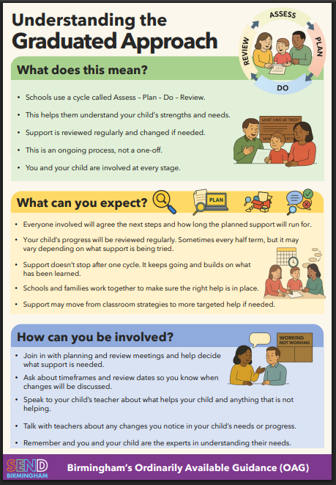

Provision
Deanery is an inclusive school, so children are taught alongside their peers wherever possible. The high-quality teaching may need to be differentiated and personalised to meet individual needs.  Class Teachers have responsibility for enabling all pupils to learn. To achieve this they:  - plan appropriate work / activities for their pupils  - ensure that support is available for all children – inclusive ‘quality first’ teaching  - differentiate the curriculum to take account of different learning styles, interests and abilities, ensuring that all children can be included in tasks / activities  - monitor individual progress  - celebrate achievements  - identify those children who require additional or different support in order to make progress  - implement targets on the One Page Profile and discuss these with parents and pupils, including through attending termly review meetings  - plan well-evidenced interventions as appropriate  Teachers are familiar with the relevant equal opportunities legislation covering the protected characteristics:  race, gender, disability, sexual orientation, religion or belief and age (See Equality Policy).  Support Staff  - sup- support teachers in enabling children with SEND to access an appropriate curriculum  - enc- encourage and promote independence in children  - liai-liaise with the Class Teacher  - hel- help to prepare resources and adapt materials  - del- deliver interventions to close gaps in learning  - pro- promote the inclusion of all children in all aspects of life at school  Support Staff, including Teaching Assistants and SEND Teaching Assistants are assigned across the whole school to support SEND pupils according to need.  The following table shows some examples of interventions and resources that are used to support children at Deanery, either within the classroom, in small groups or individually: | 
  Intervention | Resources
  - Nessy Reading and Spelling  - Continuum targets  - Bucket Time  - Little Wandle Rapid Catch-up/ KeepUp  - Precision Teaching  - Plus 1/Power of 2  - Sensory Circuits  - Hairy Reader  - Toe by Toe  - Numbots  - WellComm  - Dyslexia support  - Meet and Greet  - SCERTS  - Jolly Jungle  - Autism support  - Social Stories  - SNIP  - Life skills  - Lunchtime groups- friendships/ social skills  - Speech and Language  - Makaton  - Communication Boards  - Check-ins  - Zones of Regulation | - Calm boxes  - Barrington Stoke dictionaries  - Word banks  - Maths equipment  - Ear defenders  - Pencil grips  - Ergonomic pens/ pencils  - Wobble stool  - Wobble cushions  - Communication Boards  - Task boards  - Visual timetables  - Timers  - iPads  - Laptops  - Fiddle aids  - Photo cards  - Sensory toys  - Writing slopes  - Coloured overlays  - Zones of Regulation  - Books e.g. emotions, dyslexia friendly

External Agencies
We work with a number of different agencies to provide support, as required, for children with SEND:  - Language Learning and Strategic Support Team (LL&SS)  - Communication and Autism Team (CAT)  - Educational Psychology Service (EPS)  - Speech and Language Therapy (NHS Balanced System and independent Central Therapy Service)  - Physical Support Team (PST)  - Occupational Therapy (OT)  - Compass  - GROW  - City of Birmingham School (COBS)  Before engaging their services parents are consulted. Involvement may be through observations, 1:1 sessions or assessments. Reports or feedback information is shared with parents following any visits. |   

Staff Training
At Deanery staff are continually training and developing professionally.  The SENDCo holds the National Award for Special Educational Needs and staff receive regular training, either  - as a whole staff, for example Making Sense of Autism, Makaton, De-escalation,  - in a small focus group, for example, SCERTS, speech and language or Bucket Time training,  or  - individual attendance, for example, Drawing and Talking, Reading Ambition for All, Person Centred Reviews.  The external agencies we work with also provide advice, recommendations and training which is personalised to specific needs/ identified children. | 

Parent Partnership
At Deanery we work closely with parents and carers, recognising that a partnership between home and school will best support the child.  Parents are involved in any decision making and consulted through termly review meetings. Any involvement of agencies will be through parental consent and outcomes of any visits shared.  Throughout the year there are opportunities to meet with staff, understand the curriculum through various meetings and Open sessions, as well as Drop Ins or Coffee Mornings involving agencies.  The SENDCo can be contacted via email or phone call. | 
Pupils
Pupil voice is very important throughout the process of supporting children. They are involved in creating their One Page Profile and are encouraged to reflect on their progress through termly conversations (usually held prior to their termly review meeting).  Their interests and preferences are considered when implementing the graduated approach and planning activities and interventions. | 

Transition Support
Nursery to Reception  School staff meet with Nurseries in the local area to receive information and, where necessary, EYFS staff and SENDCo visit children beforehand at their Nursery setting. There are various events to support transition, for example, Open Sessions, Teddy Bears Picnic, Curriculum Evening.  Transitions each September  Staff meet to talk through SEND children transferring up through the school so that there is a continuity of provision. Between Key Stage 1 and Key Stage 2 there is an additional meeting for parents to explain any changes or new routines. Passports are created to further support children as they move up the school- with photos showing key adults, new rooms and changing facilities.  Secondary Transitions  During the final summer term in Year 6, members of the SEND Team at the receiving Secondary School attend the review meeting alongside current staff, primary SENDCo, parents and the child. Information is shared and there are usually additional opportunities to visit the new school. For some children, a Person Centred Review is held, involving external agencies to support transition. | 

Accessibility Plan
At Deanery, we are committed to providing an accessible environment, which values and includes all pupils, staff, parents and visitors regardless of their education, physical, sensory, social, spiritual, emotional and cultural needs. We are committed to challenging negative attitudes about disability and accessibility and to developing a culture of awareness, tolerance and inclusion.  Deanery C. E. Primary School plans to ensure the accessibility of provision for all pupils, staff and visitors to the school. An Accessibility Plan has been drawn up to cover a three year period. The plan is updated annually.  For further information, please see our Accessibility Plan. | 

Complaints
In the first instance, initial concerns should be raised with the child’s class teacher or the relevant phase leader.  If you are not satisfied that your concern has been addressed, then you can make an appointment to speak to the Inclusion Manager or Deputy Head Teacher. If they are unable to resolve the issue, an appointment can be made with the Head Teacher.  Should you need to take the matter further, the chair of governors or the SEND governor should be contacted. | 
Birmingham Local Offer
The Birmingham Local Offer can be found at  https://www.localofferbirmingham.co.uk/home/parents-and-carers/ | 

