Collective Worship

At the Deanery we engage in daily worship in which the school community will observe and encounter the living faith of Christians. Our collective worship is distinctively Christian and we aim to engage all and affect all.

We aim to help children to develop an understanding of Jesus and the Trinity
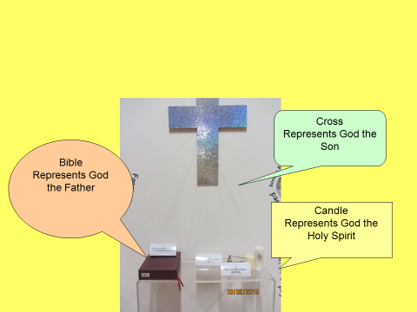

Our assemblies follow a pattern for worship reflecting Anglican tradition

Gathering – Greeting, liturgy, hymn
Engaging- Teaching, story
Responding- e.g. song, prayer, reflection, question –’what have we learnt about Jesus?’
Sending – Question e.g. ‘How can you show you’re generous? Blessing

Our collective worship follows a two-year cycle:

- 1st year – Bible stories based around the chronology of the Bible but also on the Christian calendar.
- 2nd year – Based upon our Christian values as a school (Bible stories, secular stories including famous people, world events– but with an emphasis on the Christian value each story demonstrates)

Value | Weekly themes
Faith | - Have faith in yourself  - Have faith in others  - Anything is possible with faith  - Inspirational people  - Vision  - Faithfulness  - Truth
Peace | - What is peace?  - Inspirational people  - Respect  - Honesty  - Conflict  - Acceptance
Hope | - New beginnings  - Trust  - Dreams  - Perseverance  - Patience  - Charity  - Vision
Love | - What is love?  - Kindness  - Acceptance  - Brothers and sisters  - Loyalty  - The Gift of love  - Easter
Grace | - Manners  - Politeness  - Self-control  - Gentleness  - Honesty  - Forgiveness  - Friendship
Joy | - Miracles  - Gift of God  - Charity  - Kindness  - Friendship  - Celebration  - Love  - Happiness

Deanery Values

