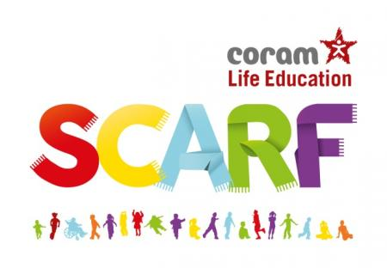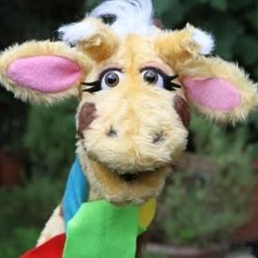
Coram Life Education is the leading charity provider of relationships, health, wellbeing, and drugs education to children across the UK. Coram Life Education & SCARF offers a whole-school approach to wellbeing and Mental Health.
SCARF – Safety, Caring, Achievement, Resilience, Friendship
Our aim at the Deanery is to equip all children with the necessary skills to take an active role in their community and manage their lives effectively, in an ever changing world. We understand that mental health and well-being is paramount and it is therefore at the forefront in our school vision and values. We believe that all children are individuals and provide them with the opportunities they need to recognise and understand their place in society. SCARF provides a clear scheme of work which we tailor to meet the needs of our pupils. Half termly teaching units and assessments are used from Nursery through to Year 6, which gives a clear progression for learning.
The Life Bus visits school in the Spring Term. Year 2,3 and 4 pupils and parents are invited to attend workshops which are once again, tailored to the needs of our pupils in our locality.
During these workshops, children meet Harold, the giraffe puppet (‘Healthy Harold’) and friends, have discussions and watch short films about healthy eating, drugs – legal and illegal – and their effects, the body and how it works, friendships and their influence, and how choices and behaviours can affect children’s health and education outcomes.
RSE is taught as part of PSHE in line with statutory guidance and is organised as a spiral curriculum, from Early Years through to Year 6. Deanery have chosen to use some parts of suggested learning from Scarf, supplemented with materials that we feel best suit the needs of or pupils.
If you would like to find out more, please refer to the RSE Policy on our website.

